BGP

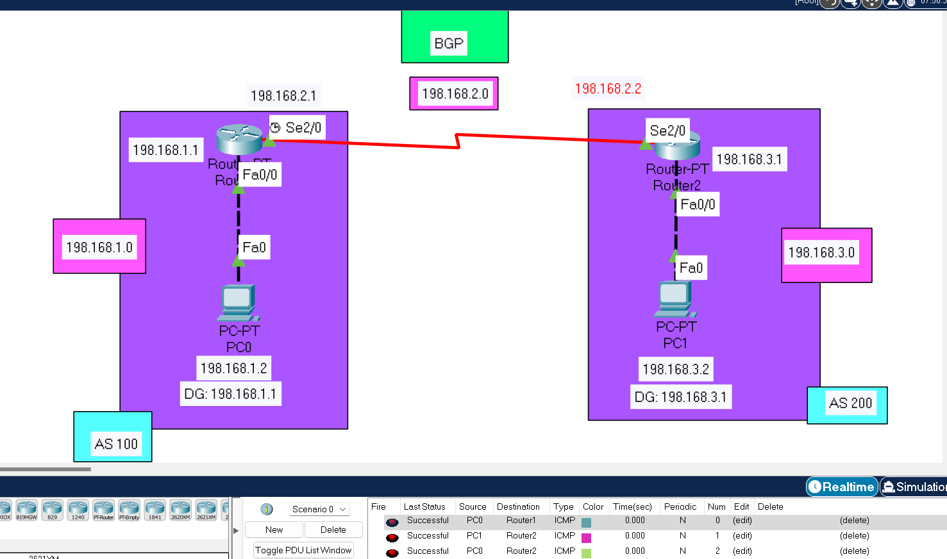

ROUTER 0

Router# enable

Router# config t

Enter configuration commands, one per line. End with CNTL/Z.

Router(config)# router bgp 100

Router(config-router)# network 198.168.1.0

Router(config-router)# network 198.168.2.0

Router(config-router)# neighbor 198.168.2.2 remote-as 200

Router(config-router)# neighbor 198.168.3.2 remote-as 200

Router(config-router)# exit

ROUTER 1

Router>enable

Router# config t

Enter configuration commands, one per line. End with CNTL/Z.

Router(config)# router bgp 200

Router(config-router)# network 198.168.2.0

Router(config-router)# network 198.168.3.0

Router(config-router)# neighbor 198.168.2.1 remote-as 100

Router(config-router)# %BGP-5-ADJCHANGE: neighbor 198.168.2.1 Up

Router(config-router)# neighbor 198.168.1.2 remote-as 100

Router(config-router)# exit